2025 Leaf Pick-up Program

The 2025 leaf season is rapidly approaching.

Beginning the week of October 6, the Huntertown Street Department will collect leaves for the Town’s 10,000+ residents. Leaf pick-up will run through November 26th, but please be advised that weather conditions or the volume of leaves in a particular area may cause the planned schedule to shift slightly.
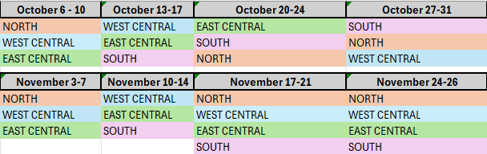
2025 Leaf Pickup Schedule:
There will NOT be leaf pickup on November 11th in observance of Veterans Day.
Leaf Pickup Guidelines:
Residents are asked to rake leaves to the park strip in front of their home. DO NOT rake leaves into the street. Leaves should be in the pick-up area by Monday at 7am of your collection week.
To help make leaf pick-up most effective for your neighborhood, please keep the following in mind:
- Rake leaves to the park strip by 7am on the first day of the week when crews will be in your area.
- Don’t put leaves in your trash or recycling cart. This is against State of Indiana law.
- Don’t bag leaves.
- Don’t burn leaves. This is a violation of Town Code and can result in a fine.
- Don’t place leaves in the street.
- Don’t place leaves in storm drains.
- Parents should remind children not to play in leaf piles near the street for safety and to assist motorists.

Residents are also able to drop off un-bagged leaves at the Huntertown Residential Yard Waste Collection Site, located by the water tower off of Cedar Canyons Road, Monday-Friday from 7:00 a.m.-3:00 p.m..
